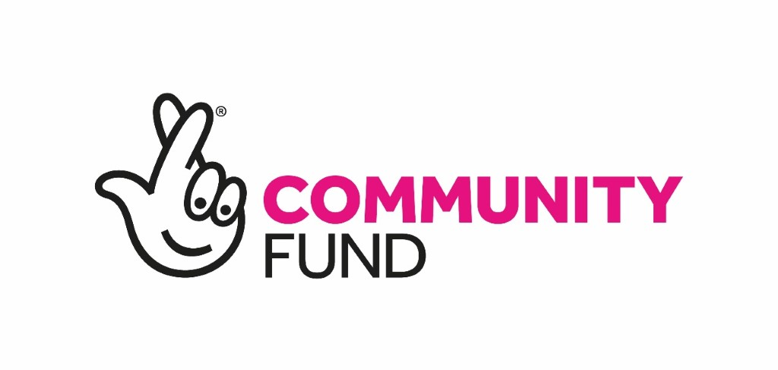

Move On Mentoring Service

Trauma-Informed Senior Development Worker

Title: Trauma-Informed Senior Development Worker
Location: Edinburgh
Responsible to: Mentoring and Employability Manager
Hours Full-time
Salary: £25,200 to £28,000 (It is Move On policy for candidates to start on point one of the salary scale)

Main Purpose of the Job

This is an exciting opportunity to develop our highly successful Mentoring service by working alongside our Mentoring team to establish Move On as a Trauma-Skilled organisation. Move On’s Mentoring for Wellbeing will build on our expertise in mentoring disadvantaged young people in Edinburgh, through increasing the capacity of our staff and volunteer mentors to support young people to improve their wellbeing and mental health.

Move On offers:

- 25 days annual leave and 9 bank holidays for the first 2 years of service, increasing to 28 days and 9 bank holidays after 3 years;
- Flexi-time;
- Option to buy additional annual leave;
- Annual personal volunteering day for staff;
- Individual training allowance and commitment to CPD;
- TOIL system.

Key Functions and Responsibilities

The Trauma-Informed Senior Development Worker will:

- Adhere to all Move On’s policies and procedures;
- To work within NHS Knowledge and Skills Framework to support Move On to be a trauma-skilled organisation;
- Provide capacity training to staff to support young people using trauma-informed principles;
- Provide specialist one to one support for mentees and mentors;
- Co-ordinate mentor matches;
- Lead on reflective practice;
- Support and supervise staff and trainees;
- Deliver mentor training to volunteers;
- Deliver capacity building training to staff and volunteer mentors;
- Support young people on a one to one basis;
- Provide support and supervision to volunteer mentors;
- Actively promote mentoring, disseminating information regarding mentoring practice and service;
- Produce service updates/reports when required;
- Ensure that the safety and welfare of individuals are protected in accordance with Move On’s safeguarding policies and procedures;
- Liaise with other agencies and practitioners to ensure a holistic approach for all individuals receiving the service;
- Work flexibly, including some evenings and weekends to meet the needs of the service;
- Participate in team meetings, regular support & supervision and training.

Creativity

- Shaping service delivery - provide a flexible response to the changing needs and circumstances of vulnerable people affected by poor mental health and other vulnerabilities;
- Supporting volunteers to play a positive role, imparting valuable information and experiences to vulnerable people to aid their transition towards their goals;
- Working alongside the Mentoring and Employability Manager to generate and implement ideas for improving service delivery and achieving outcomes;
- To understand and work within the ethos of ‘helping people to help themselves’.

Person Specification

 | Essential | Desirable
SKILLS  AND  QUALITIES | - Excellent communication skills and the ability to network well with others  - Ability to build good working relationships with vulnerable people  - Demonstrable commitment to the ethos of helping people to help themselves  - Excellent planning and organisational skills  - Ability to work on own initiative  - Experience of using a user-led approach to service delivery and development  - IT literacy, of using Microsoft applications (Outlook, Word, Excel and PowerPoint)  - Enthusiastic and self-motivated with excellent team working skills  - Strong presentation skills to promote Move On and mentoring | - Ability to manage a varied role and complex work load  - An understanding of the issues facing people affected by homelessness
EXPERIENCE | - Experience of managing, recruiting and supporting volunteers and staff  - Experience of delivering services supporting positive mental health and wellbeing for young people  - Experience of designing and facilitating training  - Experience of establishing and working in partnerships with multi-disciplinary agencies to support young people  - Experience of data collection and recording  - Experience of working in the mental health field and trauma informed enhanced practice  - Experience of supporting Wellness Recovery Action Plans  - Experience of providing advocacy support  - Educated to degree level or equivalent qualification and/or experience  - Relevant professional qualification | - Experience of participating in an ‘on call’ safety system  - Experience of carrying out monitoring and evaluation of a project or piece of work

Please refer to our web site for information about Move On
www.moveon.org.uk

The post is subject to PVG disclosure.

Closing date: Friday 14th February 2020 at midday

