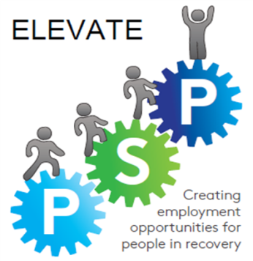
Elevate-Glasgow

FareShare Warehousing Training Course
Application Form

Name |  |  | Next of Kin
Address |  |  | Address
 |  |  | DOB
DOB |  |  | Telephone
Telephone |  |  | Relationship

DOCTOR |  |  | Medical Conditions
Address
Telephone

Prescribed Medication | Allergies

Dietary requirements | Any Other Relevant Information  (Caring responsibilities, physical health accommodation)

Equipment Requirements
Shoe Size |  |  | Clothing Size

Are you able to attend the full course? ( 17th April – 23rd May : Tuesdays & Wednesdays) | Yes No
PLEASE TURN OVER AND COMPLETE
PHOTOGRAPH/VIDEO CONSENT FORM

Please read and ensure you are fully aware of this document before you sign, should you choose to.

To comply with the UK Data Protection Act, your permission is needed before we are able to use an image or any near likeness of you. No image or likeness will be used without your permission.

If it is given, you may remove your permission at any time by contacting the person named at the bottom of this document. This form must not be signed by a minor. Permission for a minor must come from a legal guardian or parent.
PLEASE TICK THE APPROPRIATE REPOSNSE:

I do give / do not give permission as the named person above for my likeness to be used for the purposes of Elevate-Glasgow’s internal and external publications, newsletters, presentations, video and Elevate-Glasgow’s Website, and local/national newspaper articles.

DATA PROTECTION

Elevate-Glasgow PSP complies with the Data Protection Act 1998. The personal information that we collect is used to identify the most suitable service available to you. Your information will be recorded in a personal file and on a company database and will be used to produce statistical reports.

Your data will be controlled by Glasgow Council on Alcohol, the lead agency of Elevate-Glasgow PSP, and will be held as per our funding guidelines. It may be shared with other organisations within the PSP and funders.

You have the right to access your personal records by written request. For further information or to arrange to view information held about you, please contact a member of staff at Elevate-Glasgow PSP.

Please be aware that should you secure an education, employment or training opportunity whilst working with us we will:

- Share this information with our relevant partners and
- Request confirmation and/or evidence to confirm this from your education/training provider or employer up to a year after you start.

I have read and understood the above information and I confirm that
- All information given in this form is accurate and truthful.
- I agree to my details being stored and used as detailed in the Data Protection Notice.
Participant Name
Signature |  | Date

Elevate Programme Support Worker
I can confirm that I have discussed the programme with the applicant and that I believe he/she has the right attitude and commitment to gain skills and complete the personal development programme
Name
Signature |  | Date

